Statistical analysis
Alpha diversity
Alpha diversity analyses was performed using the “Shannon-Wiener” and “Simpson” diversity indexes. We considered three taxonomical levels, namely family, genus and species. Each sample was considered as an isolated ecosystem. Index distributions are reported in Figure XXX_alpha_distr and averaged in Table XXX_alpha.
Samples can also be grouped by province of origin, thus allowing investigate differences between groups. Distributions of diversity indexes are reported in Figure XXX_alpha_prov. Moreover, we performed a standard ANOVA to formally ascertain the presence of statistically significant differences between provinces. Resulting p-values are also reported in Table XXX_alpha.

Beta diversity
Beta diversity also considers information about biological richness, but measures the variation between pairs of different communities using the Bray-Curtis index. Once the (square, symmetrical) diversity matrix is obtained we applied Multi Dimensional Scaling (MDS) to allow data exploration. Results are reported in Figure XXX_beta.
Table XXX_alpha. Average values for Shannon and Simpson richness indexes for all samples, computed at three different taxa levels. Significance test p-values computed via ANOVA grouping the samples by province.
 |  | Taxa level
Richness index |  | Family | Genera | Species
Shannon | Average | 0.684 | 1.038 | 0.46
Shannon | p-value | 0.108 | 0.128 | 0.322
Simpson | Average | 0.350 | 0.557 | 0.245
Simpson | p-value | 0.083 | 0.267 | 0.285

Fig XXX_alpha_distr. Distribution of alpha diversity computed using Shannon’s and Simpson’s indexes. The three boxes report indexes computed at different taxonomic levels.
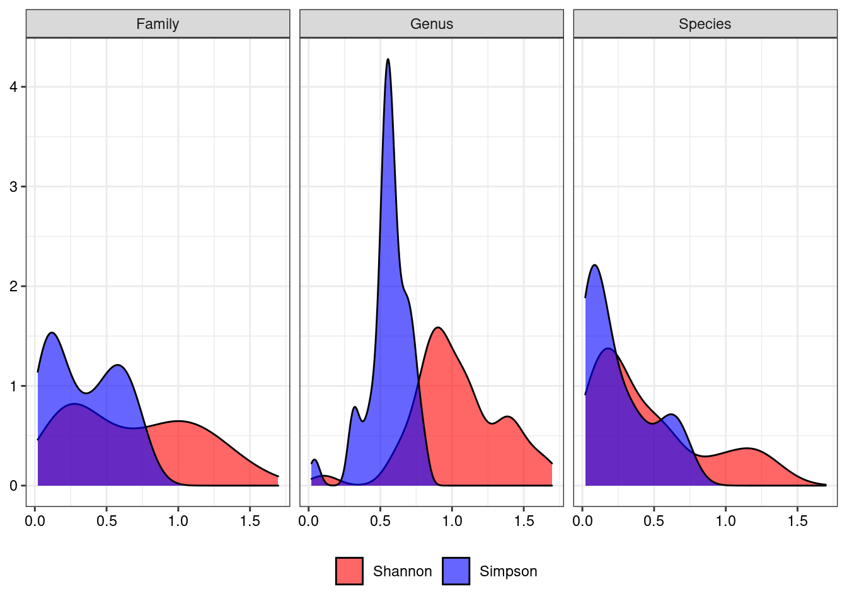
Fig XXX_alpha_prov. Distribution of alpha diversity computed using Shannon’s and Simpson’s indexes. Colours indicate different provinces of origin. The three boxes report indexes computed at different taxonomic levels.
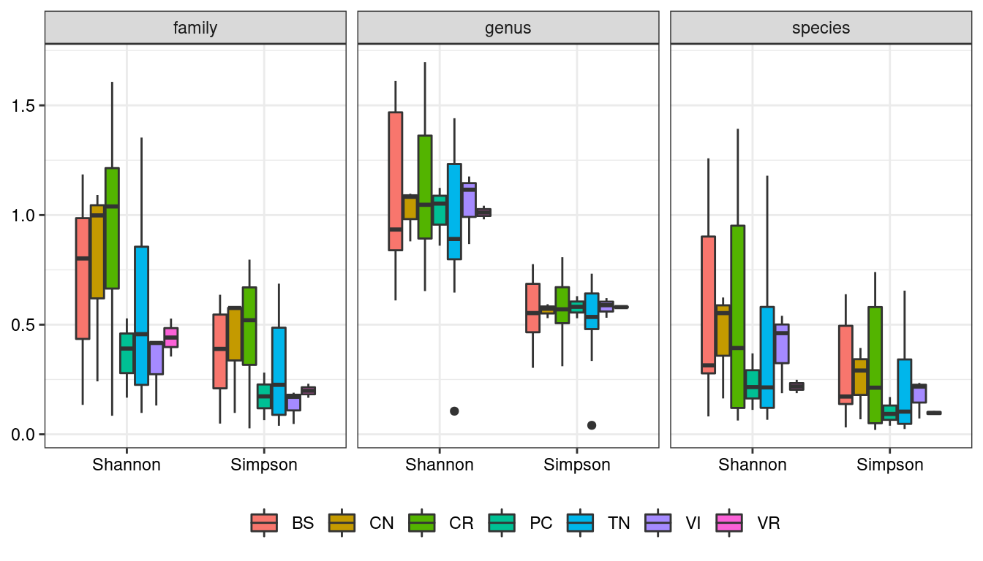

Fig XXX_beta. Diversity analysis - beta diversity. Beta diversity computed using Bray–Curtis index and then transformed via Multi-Dimensional Scaling. Samples are grouped by province.
